Biodiesel System Dynamics Model Documentation
by Richard Taylor

See also the document 'Outline for biodiesel modelling component (NEAM)'
This document is a description of the model prototype 'bioenergy_0-2' which can be found at http://modelingcommons.org/browse/one_model/4122

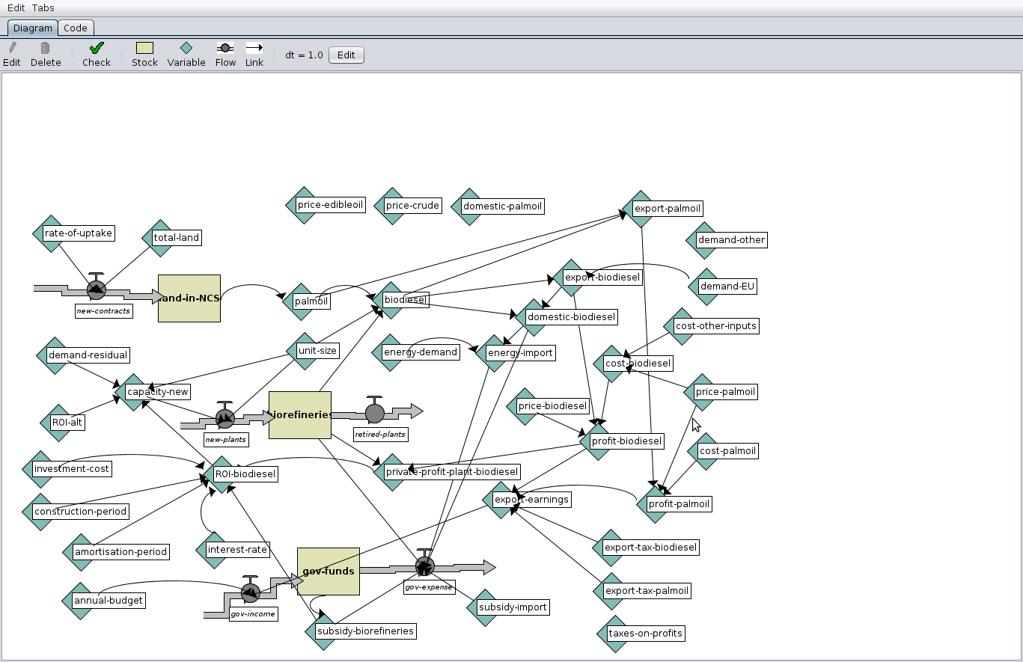
The system dynamics (SD) model prototype can be used to explore the evolution of a national biodiesel industry. The figure above shows the stocks (boxes), flows (thick arrows), variables (diamonds) and their links (thin arrows). Of the variables shown above, most of the end points /sources are exogenous parameters to the model and all other nodes are values calculated according to model equations. See the table below for further explanation of variables. Stocks are also variables but their values are stored in the model database and their state increments / decrements from one time step to the next according to calculations of flows. The three stocks are:

land-in-NCS - default starting value is 10 – this is the amount of land dedicated to palm plantations
biorefineries – starting value is 1 – number of biorefinery plants producing biodiesel from palm
gov-funds – starting value is 10000 – funds available to support biodiesel policy.

Note : real data have not been used in the prototype but all stock / variable values are test values.

variable | Default value / equation | comment
Rate-of-uptake | 1 | The number of new agreements per time
total-land | 50 | max available land to allocate to palm production
palm-oil | land-in-NCS * 100 | Production (each land plot produces 100 units)
unit-size | 100 | Amount of biodiesel each biorefinery can produce
biodiesel | min list (biorefineries * unit-size) palmoil | Biodiesel produced is the minimum of the processing capacity and the available palm feedstock
export-palmoil | palmoil - biodiesel | remaining palmoil after subtracting feedstock
demand-EU | 2000 | Demand from EU for biodiesel
domestic-biodiesel | biodiesel - export-biodiesel | Remaining biodiesel, if any, is bought at cost price by gov
energy-demand | 10000 | Domestic demand (realistically this is expected to increase)
energy-import | energy-demand - domestic-biodiesel | A major subsidy expense for the government
cost-other-inputs | 1 | Other inputs to make biodiesel (after palm oil)
price-palmoil | 3 | paid by biodiesel producers to palm producers
cost-palmoil | 2 | Costs for palm producers
profit-palmoil | export-palmoil * (price-palmoil - cost-palmoil)
cost-biodiesel | price-palmoil + cost-other-inputs | Production costs for biodiesel
price-biodiesel | 8 | Selling price for export (gov buys excess at cost price)
profit-biodiesel | export-biodiesel * (price-biodiesel - cost-biodiesel)
private-profit-plant-biodiesel | (profit-biodiesel - (export-tax-biodiesel * profit-biodiesel)) / biorefineries | Profit per plant in production accrued to biodiesel companies
export-tax-biodiesel | 0.1 | Tax rate on biodiesel export profits
export-tax-palmoil | 0.1 | Tax rate on palm oil export profits
export-earnings | (export-tax-biodiesel * profit-biodiesel) + (export-tax-palmoil * profit-palmoil) | Total gov earnings on export profits
subsidy-import | 1 | Amount paid in subsidies per unit energy
subsidy-biorefineries | ifelse-value (gov-funds <= 0) [0][1000] | Amount gov subsidy paid towards investment cost of new biorefineries (0 in the case of deficit)
gov-expense | (subsidy-biorefineries * new-plants) + (subsidy-import * energy-import) + (domestic-biodiesel * cost-biodiesel) | Three components are: price paid per new plant, cost of energy import subsidy, cost of surplus biodiesel bought at cost price (may be significantly higher than subsidy-import)
annual-budget | 10000 | Amount received each time step
gov-income | annual-budget + export-earnings
interest-rate | 0.05
amortisation-period | 20 | Period of loan for biorefinary plant costs
construction-period | 1
investment-cost | 5000 | Cost of construction of new biorefinery plant
ROI-alt | 0.02 | Return on investment producers' alternative tech. option
demand-residual | demand-EU + demand-other - export-biodiesel | Assumes the overall demand is known
ROI-biodiesel | private-profit-plant-biodiesel * (exp (- interest-rate * construction-period)) / (((1 - exp (- interest-rate * amortisation-period)) / interest-rate)* (investment-cost - subsidy-biorefineries)) | Return on investment calculation for biodiesel. Includes gov. subsidy on investment cost
capacity-new | unit-size * floor ((demand-residual / unit-size) * (ROI-biodiesel / (ROI-biodiesel + ROI-alt)) ) | Number of new plants is calculated based on ROI of each option

The final two equations have been used in other models of decision-making in the case of 'lumpy investments' (Papadelis et al. 2012). Government decision-making is simplified in the prototype to the use of fixed endogenous variables / model parameters . Below, we analyse four different experiments with fixed parameters. However it would also be possible to turn the model into a game in which the user sets the national policy relating to biodiesel (in an interactive way).

Initialisation – using default values (expt 1) and experiments with parameter changes (exp2-4)
Expt 1 with subsidy-biorefineries 1000, ROI-alt = 0.02, export-tax-biodiesel = 0.1
Expt 2 with subsidy-biorefineries 2000, ROI-alt = 0.02, export-tax-biodiesel = 0.1
Expt 3 with subsidy-biorefineries 1000, ROI-alt = 0.01, export-tax-biodiesel = 0.1
Expt 4 with subsidy-biorefineries 1000, ROI-alt = 0.02, export-tax-biodiesel = 0.2

Some indicative results
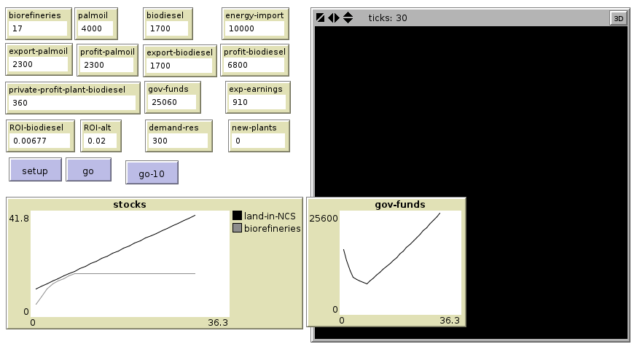
In Expt.1. (above) 17 refineries are built within the first 10 periods, gov. funds initially decreases and then subsequently recovers.

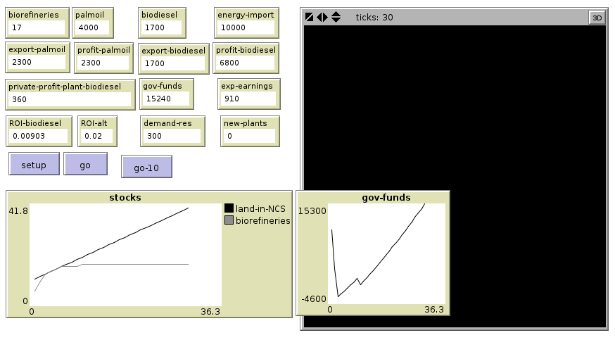
Expt. 2. (above) In this simulation subsidy to biorefineries construction is high. High ROI attracts initial take-up of industry. Howver govt. goes into debt for 1 tick and withdraws policy, takes longer to recover.

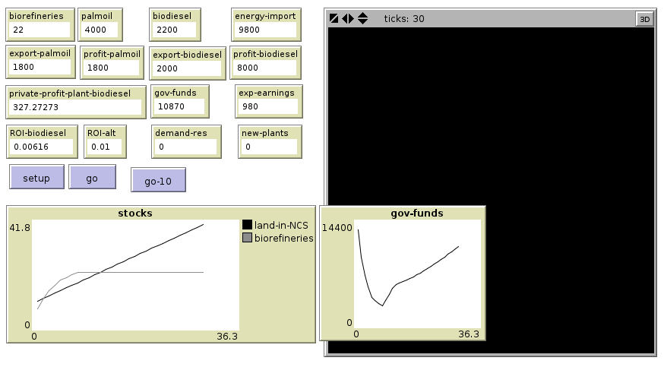
In Expt. 3 (above) ROI-alt parameter is low. There is an initially strong uptake in biorefinery (with capacity exceeding the availability of palm). Ultimately too many refineries are built (22) – there is overcapacity – which is expensive for government and also leads to a lower private profit.
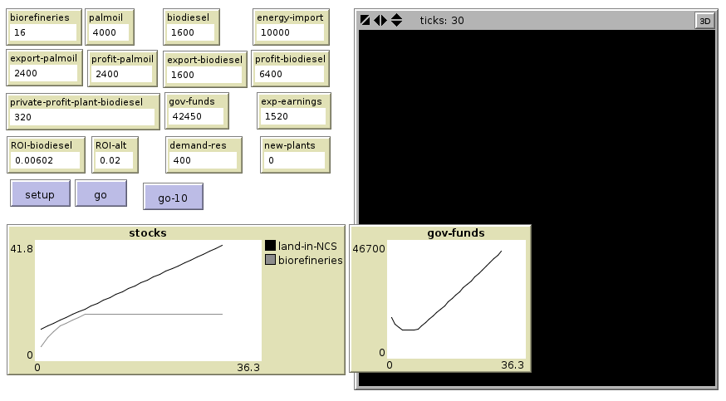
In Expt. 4 (above) export-tax-biodiesel = 0.2. Construction of biorefineries is slower and supply of palm oil exceeds demand (residue = 400) . Only 16 biorefineries are built but export earnings are still overall much higher leading to greater government funds.

References
Papadelis, S., A. Flamos, and S. Androulaki, (2012) Setting the Framework for a Business Strategy Assessment Model. International Journal of Energy Sector Management 6(4): 488–517.

Bibliography
Tahia Devisscher 2007 "The Effects of Palm Oil Biodiesel in Producer Developing Countries: A Case Analysis of Malaysia. Linking National Perspectives with Ground Realities" MSC dissertation
Palm Oil Production in Malaysia 2014 Wikipedia, the Free Encyclopedia. http://en.wikipedia.org/w/index.php?title=Palm_oil_production_in_Malaysia&oldid=617843644, accessed August 13, 2014.

